EX NO 3 Configuration and Analysis of DNS and DHCP Services for Automated Network Address and Name Management using Cisco Packet Tracer.
EX 3.1
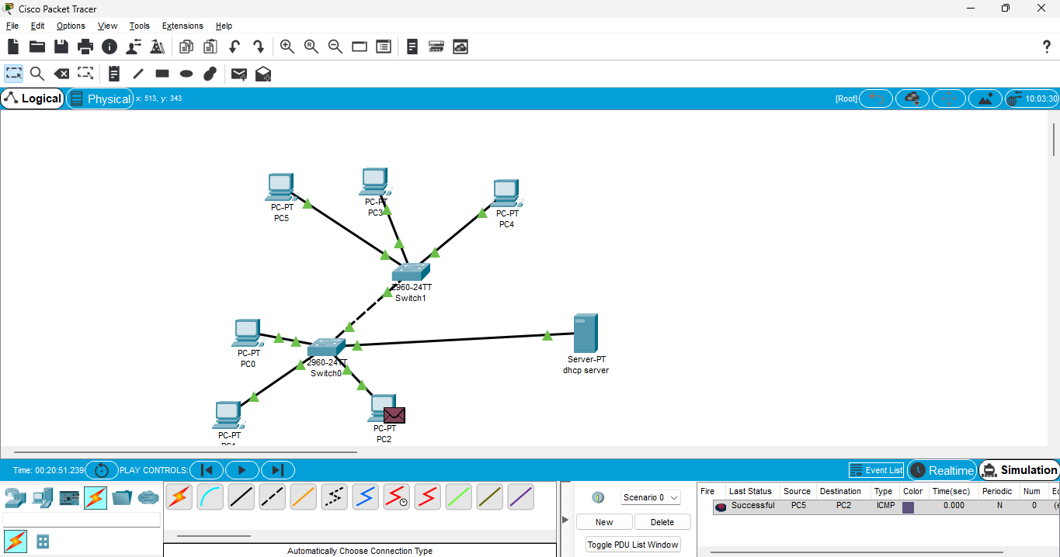
EX 3.2
